Click on File 🡪 Import, after extracting all the parts of KT Port into 1 file.

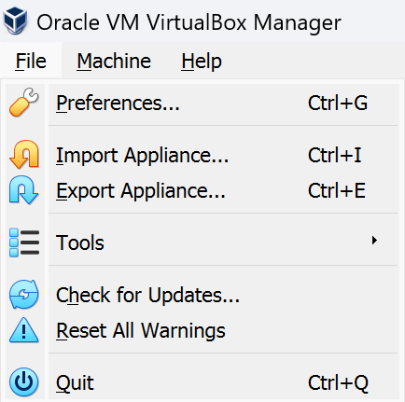 

One the Import is finished, try to start the server. Once the server start is the Password is asked then the Password would be “Oracle123”. Once you enter the machine go to path:

**C:\u01\app\server\Tomcat\bin**

And execute startup.bat file after opening the Command Prompt. After running this command your Tomcat would be up and running. And you can open a browser and enter the following URL:

<iam.example.com:6060/openam/>



This will open Access Manager.